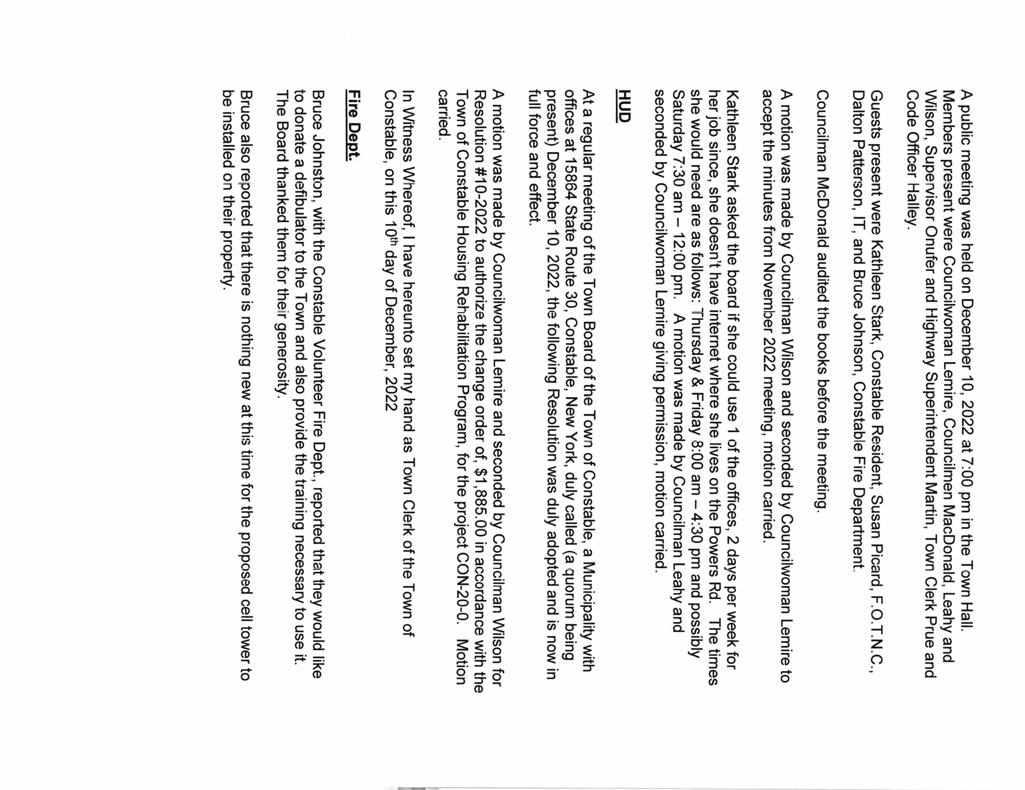
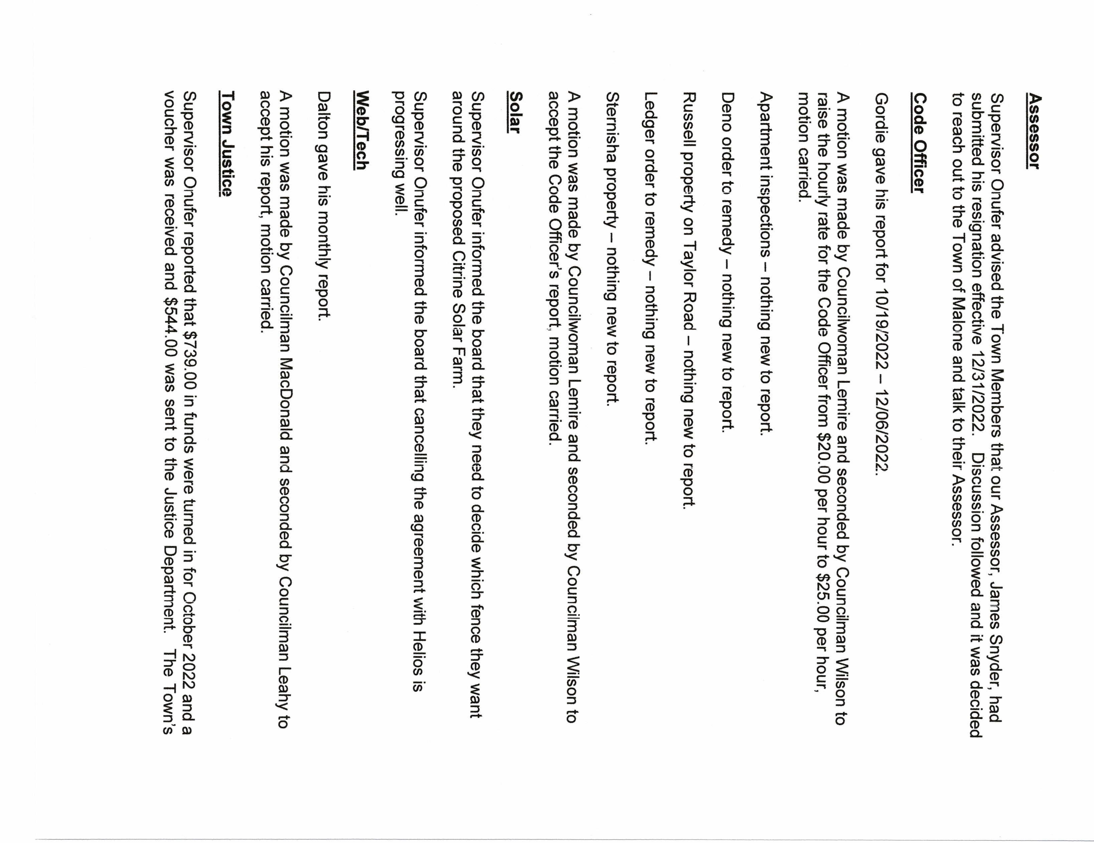

90 onwas$一95·00· S492·00wasreceived♂冖Novemberandnovoucherhasbeen receivedfromtheJusticeDeptyet

Hihwa
HighwaySuperintendentMartingavehisFuelUsage冖e0♂冖November2022·
SupervisorOne冖乛e90edthat$1060·00wasreceived omFranklinCountywhich representsthemowingfee
Tatrocomplaint|Nothingnew一0乛e90
AmotionwasmadebyCouncilwomanLemireandsecondedbyCouncilman
MacDonald一0a99乛0<eHighwaySuperintendentMartin'sNovember冖epo motion
carried
SupervisorOnuferpresentedtheHighwayDept•FundMonthlyStatementforNovember
2022fo乛allboardmembers一0review, AmotionwasmadebyCouncilwomanLemire
andsecondedbyCouncilmanLeahy一0accepttheHighwayDeptFundMonthly
Statement,motioncarried·
AmotionwasmadebyCouncilmanWilsonandsecondedbyCouncilwomanI-emire♂乛
BudgetAmendment 6,2022一motioncarried
$2094·07 omAccount#DA5一40.一|Brush&WeedsPersonalServicesGovt's

$5一096·65一乛omAccount DA5一48·一|SnowRem•,Pers•Serv•
$ 479.80 Account#DA51一0「一|GeneralRep•,PersonalServices
$4768·80一0Account#DA5一30·2,Machinery|Pers•Serv
$2742·一2♂Account DA5一42·,一SnowRemoval|Pers•Serv•
$ 387·08 Account#DA5一40.4Misc•Brush&Weeds|ContExp
$ 387b8一0Account#DA5一3P2|Equipment
$2000·00fromAccount DA5一48·一|SnowRem•,Pe乛s•Serve $2000·00♂Account#DA5一484|SnowRem•Cont•Exp•
$14404·67fromAccountFundBalance

$一967·26♂Account#DA5一48·4|Gen,Rep•ContExp•
$3一一50·5一一0Account#DA5一424|SnowRem•Cont•E)(P•

$6一809·3一一0Account DA5一3P4|EquipmentContEXP•
$4444·85一0Account#DA51一0.4|GeneralRep•ContiExp•
HighwayDept.billswereauditedandapproved一29,一42

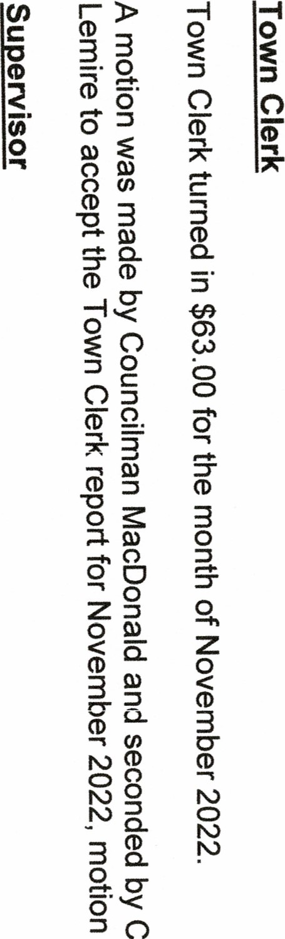
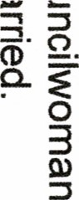
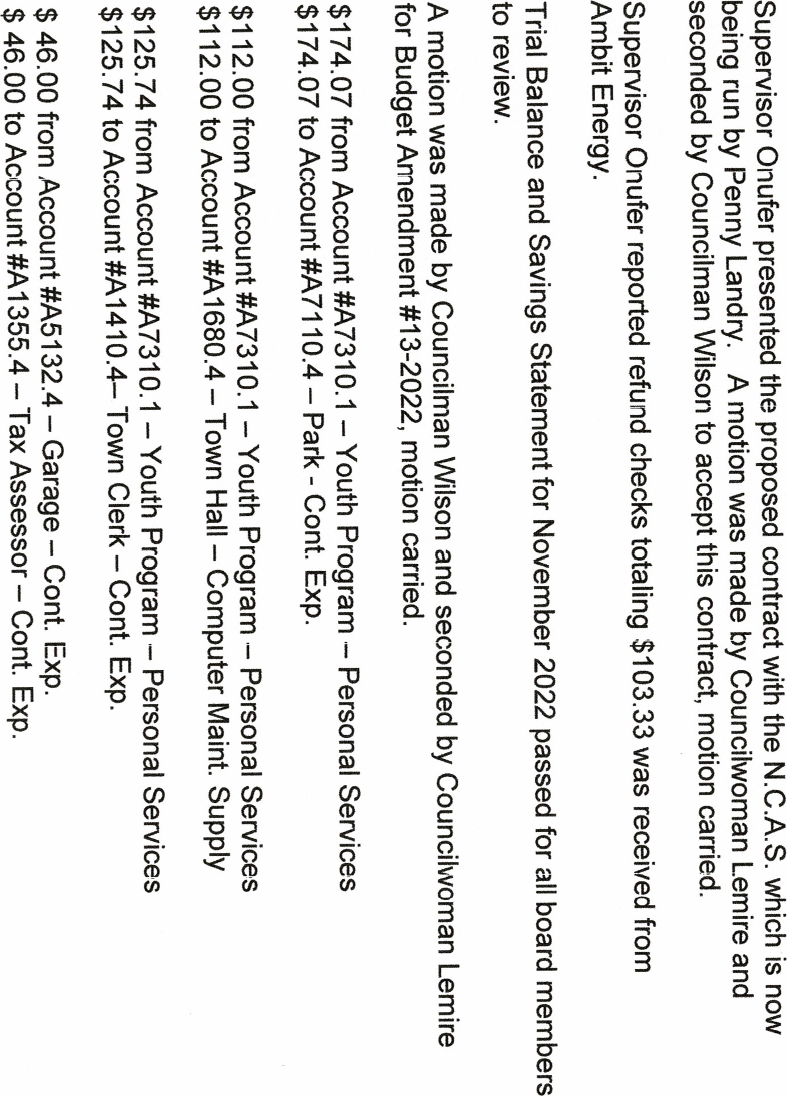 o ο 